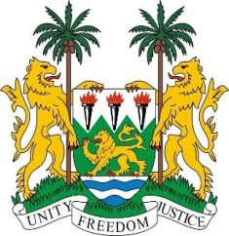
SIERRA LEONE
22nd Session of the UPR

MARSHALL ISLANDS

11 May 2015

Mr President,

Sierra Leone welcomes the delegation of the Republic of the Marshall Islands and thanks them for the comprehensive update on their national report.

My delegation commends efforts to address various human rights issues including domestic violence as evidenced in the Domestic Violence Prevention and Protection Act of 2011, the National Youth Policy and more recently, the Child Protection Policy of 2014.

Sierra Leone appreciates the financial and technical capacity constraints faced by the Marshall Islands and commends the efforts undertaken by the government to address these issues in a more holistic manner by engaging with various stakeholders at the regional and international levels. Sierra Leone also notes that the Marshall Islands are well on their way to meeting the target 4 of the MDGs of significantly reducing child mortality.

My delegation commends the government’s ongoing efforts at climate change management initiatives such as JNAP and would in this regard encourage the Marshall Islands to continue to seek technical assistance from the international community, in particular with regard to the continuing implications of radiation exposure on the health of its citizens (as a result of nuclear testing).

Sierra Leone has the following recommendations:

- Ratify the (seven) core international human rights instruments including the CAT, ICCPR, ICERD and ICESCR and their optional protocols.
- Consider establishing a national human rights institution which is in line with the Paris Principles, which would help monitor and better integrate human rights norms into national policies.
- Raise the minimum age criminal responsibility to 18 and abolish child marriage by raising the age of marriage to 18.

Sierra Leone would like to conclude by wishing the Republic of the Marshall Islands a successful completion of their national review cycle.

Thank you, Mr President.

